Comparing Precipitation Patterns in Seattle and London
Introduction
We often hear that Seattle is a very rainy city, but how rainy is it compared to other cities? To answer this question, I compared Seattle's precipitation data with London's, another city known for its rainy weather. My goal was to determine which city receives more precipitation and which experiences more rainy days.
Methods
The daily precipitation data for Seattle and London, from January 1, 2018, to December 31, 2022, came from NOAA and a GitHub repository provided by my professor. Of the 3,652 observations, 217 had missing precipitation values. To replace them, I used the average precipitation for the same day of the year across the available years, calculated separately for each city.
I compared the number of rainy days and the amount of precipitation received by each city, including monthly and seasonal differences. I also performed monthly t-tests to check whether the differences in average precipitation between the cities were statistically significant, using a significance level of 0.05.
Results
As shown in Figure 1, Seattle had 999 days with precipitation (54.7%), compared to 634 days (34.7%) in London. However, even though Seattle had more rainy days, both cities received almost the same total amount of precipitation over the five years: 206.83 inches in Seattle and 205.62 inches in London.
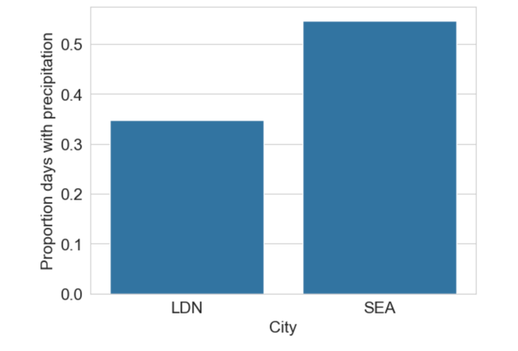
Figure 1. Percentage of days with precipitation in Seattle and London from 2018 to 2022.
Figure 2 shows that Seattle received more precipitation during winter and much less during summer. London, on the other hand, had a more even amount of precipitation throughout the year and generally received more precipitation during the warmer months.
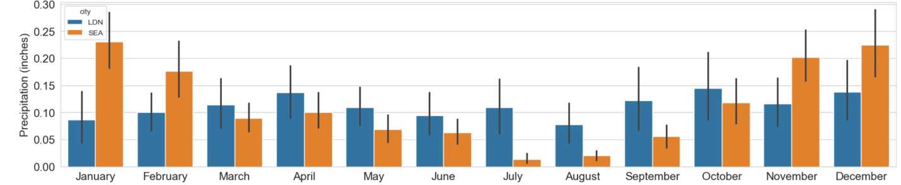Figure 2. Average monthly precipitation (inches) in Seattle and London from 2018 to 2022.
As shown in Figure 3, the differences in average precipitation between Seattle and London were statistically significant in January, February, July, August, September, November, and December, with p-values below 0.05. This means there is strong evidence that the differences in these months were not simply due to chance. In the remaining months, the differences were not statistically significant.
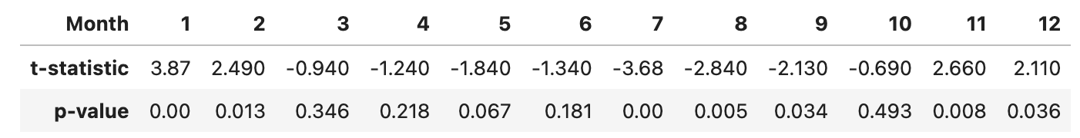 Figure 3. Monthly t-statistics and p-values comparing precipitation in Seattle and London (2018–2022).
Conclusion
So, does it rain more in Seattle than in London? The answer depends on how we measure it. Seattle had more rainy days, but both cities received almost the same total amount of precipitation. This shows that having more rainy days does not always mean receiving more rain.
One limitation of this study is that it only covers five years, which may not fully represent the weather patterns of both cities. Also, some missing precipitation values were replaced with averages, which may have affected the results. Future studies could use more years of data and compare how much rain falls on rainy days. Overall, this project helps us better understand Seattle's reputation as a rainy city and shows why it is important to consider both the number of rainy days and the total amount of precipitation.
References
National Oceanic and Atmospheric Administration. (n.d.). Climate Data Online (CDO). National Centers for Environmental Information. https://www.ncei.noaa.gov/cdo-web/search?datasetid=GHCND
Fischer, B. (n.d.). DATA-5100: Weather [GitHub repository]. GitHub. https://github.com/brian-fischer/DATA-5100/tree/main/weather

